LAB 3 – Assignment
Name: Krish Singh
Roll: AID25072
Class: AID-G sem 1

PART A
class variableBasics{
public static void main(String[] args){
int age=20;
double cgpa=8.5;
char grade='A';
boolean passed=true;
String name="Ram";
System.out.println("Name: "+name);
System.out.println("Age : "+age);
System.out.println("CGPA : "+cgpa);
System.out.println("Grade : "+grade);
System.out.println("Passed : "+passed);
}
}

Output:
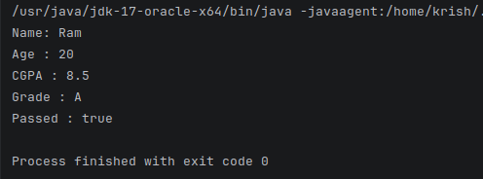

PART B

Question 1:
class variableBasics{
public static void main(String[] args){
int age;
double cgpa=8.5;
char grade='A';
boolean passed=true;
String name="Ram";
System.out.println("Name: "+name);
System.out.println("Age : "+age);
System.out.println("CGPA : "+cgpa);
System.out.println("Grade : "+grade);
System.out.println("Passed : "+passed);
}
}

Output:
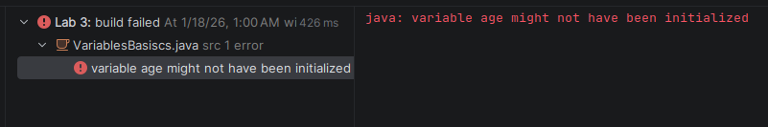

Question 2:
class variableBasics{
public static void main(String[] args){
int age="Twenty";
double cgpa=8.5;
char grade='A';
boolean passed=true;
String name="Ram";
System.out.println("Name: "+name);
System.out.println("Age : "+age);
System.out.println("CGPA : "+cgpa);
System.out.println("Grade : "+grade);
System.out.println("Passed : "+passed);
}
}

Output:
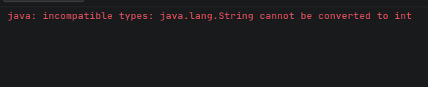

Question 3:
class variableBasics{
public static void main(String[] args){
int age=20.9876;
double cgpa=8.5;
char grade='A';
boolean passed=true;
String name="Ram";
System.out.println("Name: "+name);
System.out.println("Age : "+age);
System.out.println("CGPA : "+cgpa);
System.out.println("Grade : "+grade);
System.out.println("Passed : "+passed);
}
}

Output:
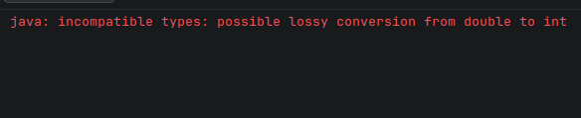

Question 4:
class variableBasics{
public static void main(String[] args){
int age=20;
double cgpa=8.5;
char grade="A";
boolean passed=true;
String name="Ram";
System.out.println("Name: "+name);
System.out.println("Age : "+age);
System.out.println("CGPA : "+cgpa);
System.out.println("Grade : "+grade);
System.out.println("Passed : "+passed);
}
}

Output:
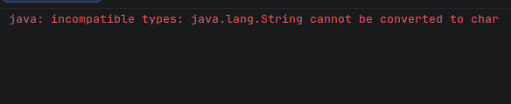

Question 5:
class variableBasics{
public static void main(String[] args){
int age=20;
double cgpa=8.5;
char grade='A';
boolean passed=true;
String name="Ram";
int age=20;
System.out.println("Name: "+name);
System.out.println("Age : "+age);
System.out.println("CGPA : "+cgpa);
System.out.println("Grade : "+grade);
System.out.println("Passed : "+passed);
}
}

output:
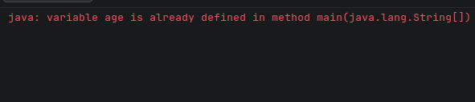

Question 6:
class variableBasics{
public static void main(String[] args){
age=20;
int age=20;
double cgpa=8.5;
char grade='A';
boolean passed=true;
String name="Ram";
System.out.println("Name: "+name);
System.out.println("Age : "+age);
System.out.println("CGPA : "+cgpa);
System.out.println("Grade : "+grade);
System.out.println("Passed : "+passed);
}
}

Output:
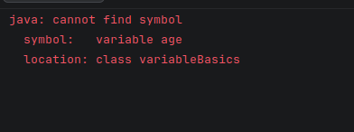

Question 7:
class variableBasics{
public static void main(String[] args){
int age=20;
double cgpa=8.5;
char grade='A';
boolean passed=true;
String name="Ram";
System.out.println("Name: "+name);
System.out.println("Age : "+age);
System.out.println("CGPA : "+cgpa);
System.out.println("Grade : "+grade);
System.out.println("Passed : "+passed);
}
}

output:
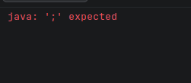

Question 8:
class variableBasics{
public static void main(String[] args){
int 123age123=20;
double cgpa=8.5;
char grade='A';
boolean passed=true;
String name="Ram";
System.out.println("Name: "+name);
System.out.println("Age : "+age);
System.out.println("CGPA : "+cgpa);
System.out.println("Grade : "+grade);
System.out.println("Passed : "+passed);
}
}

Output:
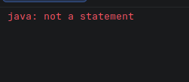

PART C
class variableBasics{
public static void main(String[] args){
int age=20;
double cgpa=8.5;
char grade='A';
boolean passed=true;
String name="Ram";
int year=2;
String department="CSE";
System.out.println("Name: "+name);
System.out.println("Age : "+age);
System.out.println("CGPA : "+cgpa);
System.out.println("Grade : "+grade);
System.out.println("Passed : "+passed);
System.out.println("Year : "+year);
System.out.println("Department : "+department);
}
}

Output:
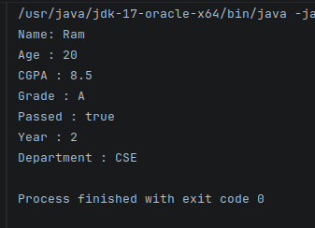

Question 1
Ans: Variables in java are the named memory locations that store a certain type of value which can be used or changed during program execution.

Question 2
Ans:A variable must be declared before use so that the compiler knows its data type, memory requirements, and scope, ensuring type safety and preventing errors.

Question 3
Ans: If we don’t initialize a local variable it gives an error: ‘Compile-time error: variable x might not have been initialized’ . This compile time error occurs because local variables don’t have a default value, unlike instance or static variables.

Question 4
Ans: Java does not allow assigning text to int because its a statically typed programming language meaning the variable data types need to be specified, also java has strong type casting which prevents a variable of certain data types from storing values other than that data type specified, like example storing text in int.

Question 5
Ans: The first difference is that character is primitive data type and string is non primitive data type in java. Char stores single character while String stores a series of characters. Char is written/enclosed within single quotation (‘A’) while string is stored within double quotes (“Krish”). Char takes 2 bytes while Strings size depends on the length.

Question 6
Ans: Semicolon is important to terminate the line of code. It marks the end of a statement and tells the compiler that the instruction is complete.

Question 7
Ans: Redeclaration means declaring a variable with the same name multiple times within the same scope, which is not allowed in java and gives a compile time error
‘Error: variable a is already defined’

Question 8
Ans: Variables name invalid in Java are as follows:
1. int 123file; – name cant start with a number.
2. int @series; – name cant start with special characters except ‘_’ and ‘$’.
3. int ; - names cant be empty.
4. int total marks; - names cant have spaces in between.
5. int class; / int static; - names cant use keywords.

Question 9
Ans: One of the error I faced was due to assigning value to a variable before declaring a variable. The error message was ‘error: cannot find symbol’. In Java the data type of the variable must be known before assigning a value to the variable and store the value in the variable. Before declaration the variable does not exist in the memory. I fixed the error by assigning value to the variable after declaring it.

